**BUS/CU/HRM/BC/04/6: ENTREPRENEURSHIP EDUCATION/ DEMONSTRATE UNDERSTANDING OF ENTREPRENEURSHIP**

**Learning Outcomes**

**List of learning outcomes**

a) Demonstrate understanding of who an entrepreneur is

b) Demonstrate knowledge of entrepreneurship and self-employment

c) Identify entrepreneurship opportunities

d) Create entrepreneurial awareness

e) Apply entrepreneurial motivation

f) Develop business innovative strategies

g) Develop business plan

**Introduction**

This learning outcome aims at equipping the trainee with knowledge of understanding best

who is an entrepreneur, who he socially is, his characteristics, how an entrepreneur differs

from business person, types of entrepreneurs, characteristics of entrepreneurs, factors

affecting entrepreneurship, development as per the principles of entrepreneurship.

**Definition of key terms**

**Entrepreneur:** It is a person who creates initially small business and strives to maximize

potential of their venture while simultaneously minimizing risk.

**Entrepreneurship:** This is a process of designing, launching and running a new business

which often initially a small business along with its financial risks.

**Self-employment:** This is where an individual is in control of his/her own business, makes

decisions affecting and enjoys all the profits of that business and incurring all the losses.

Business environment: Are those factors that affect the operations of a business. They

may be internal or external environment.

**Small scale enterprises:** It is a type of an enterprise marked by a limited number of

employees and limited flow of materials and finances.

**DISTINCTION BETWEEN ENTREPRENEURS AND BUSINESS PERSON**

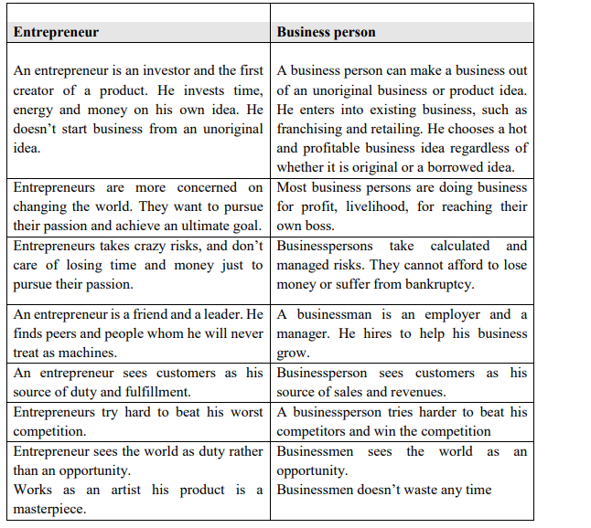

**Types of entrepreneurs**

a) **Innovator:** They come up with completely new ideas and turn them into viable

business ideas.

b) **Imitators:** They are the types who copy certain business ideas and improve upon

them.

c) **Small scale entrepreneur:** It is a type of entrepreneur that involves small business

ventures. They lack the scale to attract venture capital but are funded by family and

friends. Examples are; groceries, Consultants, carpenters and hairdressers.

d) **Scalable start-up entrepreneur**: Entrepreneurs start their company believing that

their vision can change the world. Their funding comes from venture capital and

they hire the best employees. Finding a scalable and repeatable business is the

ultimate goal of the business. Examples are; Facebook, online shops, Instagram etc.

e) **Large company entrepreneurship:** through sustaining innovation, offering new

products in order to meet with changing customers’ needs and advanced

technology. Often companies do this by partnering with or buying innovative

companies. Examples are; Microsoft, Samsung, Google, etc.

f) **Social entrepreneur:** It is where an entrepreneur creates product and services to

solve social need and problems. This can be non- profit, profit or hybrid. E.g. safe

point trust by Marc koska which works to redesign medical tools and introduce

inexpensive non-reusable syringes for underfunded clinics the world.

**Advantages/Importance’s of entrepreneurship**

• Create jobs: As much as entrepreneurs create job themselves. They also create a

number of jobs opportunities with their business venture and as their businesses

grow so the opportunities available increases.

• Creates change: When entrepreneurs make a product or explores ideas, it brings in

change and improvement in the world.

• Entrepreneur give to the society: The more the money they make the more in taxes

they pay which in turn funds public services. E.g. Bill Gates the founder of

Microsoft is the biggest donor in charities and non-profit organization.

• Entrepreneurship have independence: They are their own boss this enables to work

to their capacity and towards achieving the specific goal.

• Freedom of ideas: They are free to implement and make any change in the operation

of the business.

**Disadvantages of entrepreneurship**

• Risk of business failure - There is no certainty of success.

• Long working hours especially in early stages of implementation.

• Income is varied and uncertain - It is difficult to estimate the income that you will

be able to get in particular day or month.

**Identify ways of becoming an entrepreneur**

• Be a risk taker: Humans are generally risk averse, but part of being an entrepreneur

is recognizing the risk that you should take. Successful entrepreneurs know which

risk to take and which they shouldn’t.

• Exercise: That is put the idea into action

• Learning: Getting new ideas from established entrepreneurs.

• Networking: Analyzing gaps in the market where you can invest in and working

together with entrepreneurs of your area of specialization.

• Trust yourself: Being determined to achieve your goals.

• Challenge yourself: Compare yourself with the already established entrepreneurs.

• Visualize goals: Determine the needs and requirements of your goals.

***Characteristics of entrepreneurs are identified as per the principles of***

***Entrepreneurship.***

**Characteristics of Entrepreneurs**

• Self-motivated: when you want to succeed you need to be able to push yourself.

You aren’t answerable to anyone else as an entrepreneur and that means that it’s

hard to get moving without anyone to make you.

• Risk taker: successful entrepreneurs know that sometimes it’s important to take

risks. Playing it safe sometimes never lead to success as a business owner.

• Flexible: Have the ability to be able to change as needed. Staying on top of your

industry and be ready to adopt changes in the process and product as they are

needed.

• Passion: Successful entrepreneurs are passionate. They feel deeply about their

product or service or mission.

• Basic money management skills and knowledge: Understand how money works

so that you know where you stand and so that you run your business on sound

principles.

• Network: Being able to connect with others and recognize partnership

opportunities can take you a long way as a business owner.

***Factors affecting entrepreneurship development are explored as per principles***

***of Entrepreneurship***

**Entrepreneurship is influenced by various factors:**

• Economic development.

• Culture.

• Technological development.

• Education.

• Political factor

• Legal factor

• Capital

These conditions may have both positive and negative influences on the emergence of

entrepreneurship.

a) Economic factors: Economic environment exercise the most direct and immediate

influence on entrepreneurship. These factors include:

• Capital.

• Labor.

• Raw materials.

• Market.

• Infrastructure.

b) Social factors: These can go a long way in encouraging entrepreneurship. In fact it

was the highly helpful society that made the industrial revolution a glorious success

in Europe. Main components of social environment include:

• Caste factor.

• Family background.

• Attitude of the society.

• Education.

• Cultural values.

c) Technological factors: Technology has influenced entrepreneurship development

through innovations and use of internet to gather new and existing information.

d) Education: Many entrepreneurial theorists have propounded theories of

entrepreneurship that concentrates especially upon psychological factors. They may

include:

• Need achievement.

• Withdrawal of status respect.

• Motives.

e) Political and government changes in government policy can have a very huge

effect on the business in question. Example the tobacco industries have been on

forced to put warning labels on their product and lost the right to advertise on the

television.

**Conclusion**

This learning outcome covered on the distinction between entrepreneurs and

businesspersons, identify types of entrepreneurs, identify ways of becoming an

entrepreneur, identify characteristics of entrepreneurs and explore factors affecting

entrepreneurship development as per the principles of entrepreneurship.

**KNOWLEDGE OF ENTREPRENEURSHIP**

**Definition of key terms**

**Entrepreneurial traits:** These refer to characteristics of entrepreneurship and are always

possessed by the entrepreneurs. All the entrepreneurs possess these characteristics and they

distinguish them from the other persons.

**Entrepreneurship culture:** It is the behavior that is possessed by most of the individuals.

Are also the attributes, values, beliefs, and behavior in which an individual learns from one

generation to another i.e., behaviors of carrying out entrepreneurship activities e.g. starting

up a business.

**Self-employment**: This is where one is his/her own boss, is in full control of the business,

makes all decisions affecting the business and enjoys all the profits of the business or incurs

all the losses of the business.an individual can even hire employees to work for him or her.

**National Development:** This explains the benefits accrued from entrepreneurship to the

nation. It may include benefits like revenues, employment, cohesion, infrastructure [lights

roads, electricity] increased imports and exports among others.

**Distinguish between entrepreneurship and self-employment**

To distinguish means recognizing the differences between two aspects in this case

entrepreneurship and self-employment.

***Differences between entrepreneurship and self-employment***

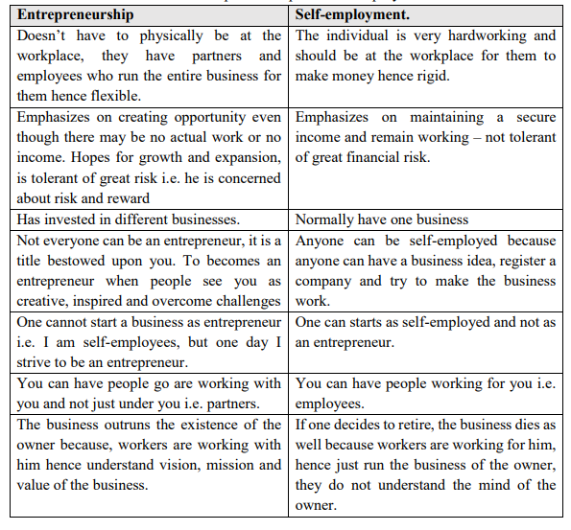

**The importance of self-employment**

To analyze means to interpret and explain in detail the importance of self-employment

based on business procedures and strategies. The importance includes:

i. Being your own boss

One is control of all key decisions affecting his business because it is your business you

have started. You work for your clients. Clients state what results they expect from you,

but they do not direct your work. You are your own boss therefore you decide when and

where and how to work to get the job done.

ii. Flexibility

To decide hours of operation, working conditions, business location. You do not have to

go where your employer forces you to do work.

iii. Harmony with your life

If you are working for yourself, chances are you will be doing ok that you enjoy hence self-fulfillment.

iv. Income generating

If all goes well and you are making money, chances are you will make more money than

you did while working for someone else.

v. Profitable

You get to enjoy all the business profits. If your business is doing well, you may not have

to share proceeds with anyone else. The fruits of your labor will all be yours because you

own the vineyard.

**Requirements for entry into self-employment**

i. Identify business structure: Determine whether your business will operate as a sole

proprietorship or partnership. You can also set your business up as a limited liability

company or as a corporation.

ii. Register your business: Apply to receive employer identification number. Also

register your business with state and local tax offices.

iii. Licenses and permits: Seek for licenses and permits required to operate a business.

iv. Record keeping: Create and maintain accurate records. Items to list in your records

are details of customers, dates sales or purchases, number of sales, taxes collected on

sold items and unsold.

v. Taxes – be aware of the taxes that apply to the business to ensure you are fully

compliant.

vi. Will you enjoy your work? – You can only run a business you are passionate about

because it brings happiness that satisfies your life goals. You will have to run a

business that fills the sense of your purpose.

**The role of an entrepreneur in business**

• Initiator: One who initiates the process of creating a business by coming up with

the idea for the business and planning out how to turn that idea into a reality.

• Risk taker: He is the biggest risk taker in business because he is the one who invests

capital and accountable in the face of failure.

• Allocator: He allocates various resources in the organization. These resources

include; manpower, machines, funds, etc.

• Forecasting: He should be prepared on how to deal with various forecast changes

such as strikes, machine breakdowns, budget cuts, legal policies, political or social

unrest, technological advancement etc.

• Adhering to legal norms: To ensure the enterprise adheres to legal norms and

policies. Not pertaining to this can mean serious legal consequences.

• Reduces risk: Best achieved by bringing people that can help the organization

grow. These people can be stakeholders or investors that have stake in the company.

**The contributions of entrepreneurs to national development**

• Entrepreneurs spur economic growth. New products or services created by

entrepreneurs can produce a cascading effect, where it stimulates relate businesses

or sectors that need support the new venture, furthering economic development.

• Boosts national income. Entrepreneurial ventures help generate new wealth,

additionally, increased employment and higher earnings contribute to better national

income in the form of higher tax, revenue and higher government spending.

• Entrepreneurs create social change. Through offering unique goods and services,

entrepreneurs break away from tradition and reduce dependence on obsolete

systems and technologies.

• Community development. Entrepreneurs regularly nurture venture by other

likeminded individuals. They also invest in community projects and provide

financial support to local charities.

• Conservation of foreign exchange – You are able to produce goods hence no need

to import therefore contributing to conservation of foreign exchange.

• Promotion of entrepreneurial culture – They encourage individuals to set up and

manage their business and this reduces importation of goods.

**Entrepreneurship culture in Kenya**

* Entrepreneurship culture in Kenya is influenced by the following factors:
* Availability of funds
* Modern technology
* Availability of developed infrastructure
* Appropriate knowledge and skills
* Appropriate training
* Government policies
* Individual strength and talents
* Availability of markets
* Availability of resources
* Culture
* Natural factors
* Political stability
* Competition
* Resource persons and entrepreneurs
* Social security

**Born or made Entrepreneur’s traits**

Born entrepreneurs dream big, take what they want and never stop trying to achieve their

goals. They have the following traits:

* Believe in themselves
* Have some security
* Takes charge
* Crafty and innovative
* Outspoken
* Observed with making money
* Fearless and thrive on challenges
* Take huge financial risks

• They can have a business idea that doesn’t have to bring income instantly when it

is implemented.

Made entrepreneurs are those that are self-made successful individuals. They may have

different traits from those who were successful before. They have the following

characteristics.

* Determined.
* Enjoy what they do.
* Serious.
* Risk taker.
* Can manage money.
* High level of confidence.
* Recognizes failure.
* Plan everything.

**Conclusion**

This learning outcome enhanced on distinguishing between entrepreneurship and self-employment, analyzing of the importance of self-employment, and determining the roles

of an entrepreneur in a business. It also tackled on requirements for entry into self-employment, understanding the role of an entrepreneur in national development and explore the various entrepreneurship cultures in Kenya in accordance to business procedures and strategies. Lastly, it covered on the distinction between Born and made Entrepreneurs as per entrepreneurial traits.

**ENTREPRENEURSHIP OPPORTUNITIES**

**Definition of key terms**

**Sources of business:** These are the origins of business idea that can be used for financial

gain that is centered on a product that can be offered money.

**Product demand:** A customer’s willingness to purchase a product or services at a given

price.

**Business life cycle:** They are phases that a business idea passes through from the time it is

formed in the entrepreneur’s mind to the time business rolls and expands or declines.

**Business legal aspects:** They are legal frameworks through which a business operates.

**Sources of business ideas include:**

• Customer surveys: Customer needs and wants to justify for the service or product

that you can offer them.

• Interests and hobbies: Most people have founded great successful businesses

while pursuing their interests and hobbies i.e. by doing what they love doing in their

leisure times.

• Brainstorming and dreams: This starts with identifying a problem statement or

question. Designing solution to these problems lead to business ideas.

• Franchising: It is a situation where sole traders mark distributor of a product gives

exclusive rights to independent retailers for local distribution.

• Mass media: Include T.V. newspapers, internet, radio, and magazines. They are

also, a great source of ideas, information and opportunities.

• Personal experience and talents: Most of the ideas are also as a result of

experience in a workplace.

• Trade fairs and exhibitions: Attending such events regularly makes one discover

new services and products.

Generate business ideas and opportunities

To generate more business ideas and opportunities, one must be able to do the following:

• Meet new people

• Tap into your interests

• Keep “pain point” journal

• Travel

• Explore new ways of thinking

• Do your market research

• Go online

• Attending educational events

**Business life cycle**

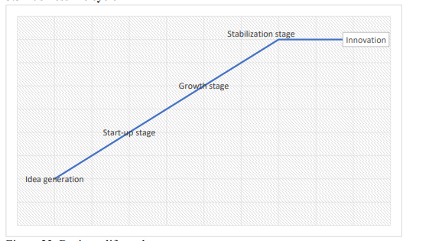

**Business life cycle**